Logo color: Gunmetal  
Code: #1E2631

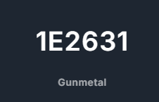

**Font details**

EE: **Cooper BT**

Educational Enterprise: **Trajan Pro**

Estd. 1961: **Forum**

Pvt.Ltd.: **Forum**

**Logo versions**

Primary horizontal with Pvt.Ltd (only this logo has Pvt.Ltd)

Primary horizontal

Primary vertical

Logo icon

Logo text